**End Term Project**

Contents

Executive Summary 3

Research Methodology 3

Competitor Analysis 4

Pre-Purchase Stage 10

Marketing Implications of Pre-Purchase Stage 11

Decision-Making Model: Compensatory Decision Rule 11

Purchase Stage 12

Correlation Analysis in the Purchase Stage 12

Consumer Behavior Frameworks in the Purchase Stage 13

Regression Analysis Results 15

Post-Purchase 19

Analysis 19

Recommendations 21

Marketing Problems 21

Marketing Opportunities 21

Exhibits 22

References 24

# Executive Summary

T

his report provides an in-depth analysis of consumer behaviour surrounding the Tata Harrier, focusing on pre-purchase, purchase, and post-purchase stages. It examines factors influencing customer satisfaction, potential cognitive dissonance, and word-of-mouth behaviour, along with comparative insights into key competitors such as MG Hector, Hyundai Creta, and Kia Seltos. The research integrates quantitative data from an online survey and qualitative insights from focus group discussions, providing a comprehensive understanding of the consumer decision-making process and its implications for Tata Harrier's marketing strategy.

The insights from the pre-purchase, purchase, and post-purchase stages of SUV buyers, particularly MBA students and young professionals, highlight key consumer behaviors and preferences. In the pre-purchase stage, lifestyle needs like weekend trips and family growth drive interest in SUVs, with digital sources such as automobile reviews and YouTube being highly trusted. Tata and Toyota are preferred for test drives. During the purchase stage, fuel efficiency, price, and brand reputation are critical factors for satisfaction, with younger consumers prioritizing performance and price, while older buyers emphasize comfort and safety. Post-purchase, most Tata Harrier owners report high satisfaction and strong brand loyalty, showing a willingness to recommend the vehicle despite minor regrets. Competitors like MG Hector, Hyundai Creta offer alternatives, but Tata Harrier's focus on brand loyalty, safety, and affordability gives it a competitive edge. For marketing, Tata should strengthen its digital presence, focus on fuel efficiency and price in its messaging, and tailor content to different consumer segments—performance for younger buyers and comfort for older ones—while leveraging its brand reputation to build trust and reduce perceived risks.

# Research Methodology

This research aimed to understand customer satisfaction, potential buyer's remorse (cognitive dissonance), and word-of-mouth behaviour following the purchase of a Tata Harrier. The data collection process involved both quantitative and qualitative approaches, offering a well-rounded view of the post-purchase experience.

**Data Collection:** An online survey was shared with MBA students and professionals. This survey sought feedback on the Tata Harrier's post-purchase attributes. The data collected was analysed using SPSS software for statistical insights. Additionally, a focus group with 7 participants provided in-depth perspectives on what features consumers prioritize in vehicles like the Tata Harrier. The insights from this focus group added to the understanding of consumer behaviour and preferences.

**Sample:** A total of 25 individuals participated in this study. Along with analysing perceptions of the Tata Harrier, data on competing vehicles like MG Hector, Hyundai Creta, Jeep Compass, and Kia Seltos was considered to provide comparative insights.

# Competitor Analysis

**Tata Harrier**[1] [2] [3]

* **Strengths**
  + Design: The Harrier's bold design is a head-turner on the road.
  + Comfort: The Harrier's spacious interior is comfortable for both driver and passengers.
  + Safety: The Harrier has impressive safety with 7 airbags and received a five-star rating from the NCAP authorities.
  + Performance: The Harrier's 2.0-litre diesel engine makes driving fast and effortless.
  + Gearbox: Tata Harrier has a power full A6F36 embedded automatic gearbox.
  + Engine: Harrier has a 1956 cc diesel engine that is available with manual and automatic transmission.

1. **Weaknesses**
   * Quality: Some say the Harrier has room for improvement in terms of quality and attention to detail. For example, one reviewer noted that the steering wasn't aligned properly and the finish around the gear lever was poor.
   * Fuel economy: Some say the Harrier's fuel economy is not as sensible.
   * Infotainment screen: Some say the infotainment screen could have been bigger and offered snappier responses.
   * Hydraulics: People expected some more suspension in the vehicle002E

* **Opportunity** 
  + ConnectNext feature: This feature was removed from the 2021-22 Harrier's infotainment in the 18.64 update.
  + Spare wheel: The Smart and Pure variants do not come with a spare wheel.
* **Threats** 
  + E Vehicle: Influence of market towards to EV can make drastic swift in Harrier’s demand.
  + Close Competition: If you are less competitive, you might be out of the race.
  + Strict Regulations: Government is coming up with strict policies on petrol and diesel vehicle to achieve 2050 sustainable goals.

**MG Hector**[4] [5]

1. **Strengths**
   1. Spacious and comfortable: The MG Hector has a roomy cabin with comfortable seats.
   2. Good performance: The MG Hector has a premium look.
   3. Good fuel economy for the diesel engine: The diesel engine has better fuel economy than the petrol engine.
   4. Good braking: The MG Hector has good braking, even at high speeds.
   5. Good night visibility: The MG Hector's headlights provide good visibility at night.
2. **Weaknesses**
   1. Low fuel efficiency for the petrol engine: The petrol engine has low fuel efficiency.
   2. Limited after-sales network: MG is a relatively new brand in India, so its after-sales network is limited.
   3. Limited space in the third row: The third row in the Hector Plus is only suitable for children.
   4. Touchscreen issues: The touchscreen can be impractical and laggy.
   5. Voice command issues: The voice command may not recognise what you say or may listen to the wrong thing.
   6. 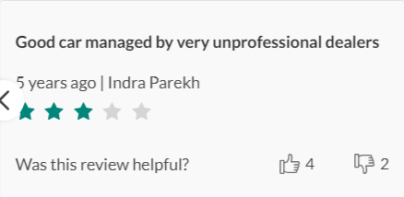Cooling issues: The rear AC may not be effective in summer due to the panoramic sunroof.

**Kia Seltos**[6] [7]

* **Strengths**
  + Interior: The cabin is spacious, with plenty of room for passengers and cargo. It also has a high-quality interior and a large 10.3-inch infotainment screen.
  + Practicality: The Seltos is a practical, comfortable, and good-value SUV.
  + Stability: The Seltos is stable at speeds up to 120 kmph.
* **Weaknesses**
  + Windshield reflections: The windshield can distract the driver due to reflections from the high noon sun.
  + Engine noise: The engine can be loud, even when the radio is off.
  + Safety: The Seltos received a 3-star rating from Global NCAP due to an unstable bodyshell and poor head protection performance.
  + Engine issues: Some 2021 Kia Seltos vehicles with 2.0L Nu MPI engines had engine damage due to improperly heat-treated piston oil rings.
  + 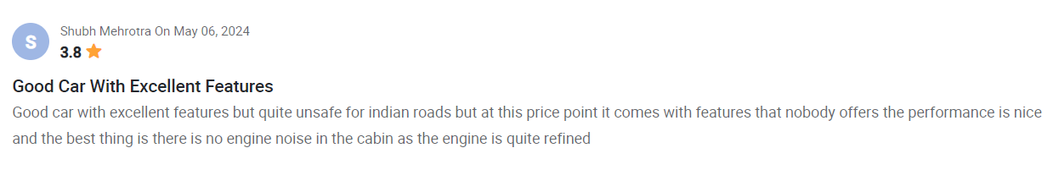Mileage: Some say the Seltos doesn't get as good mileage as its competitors.

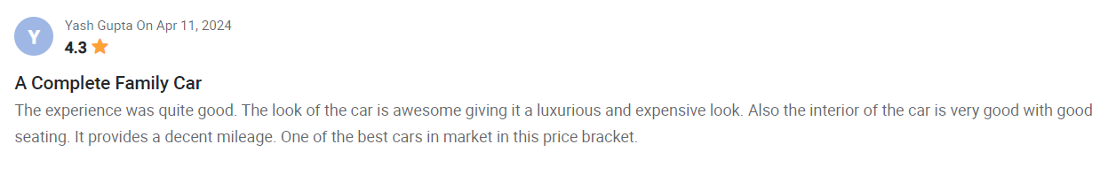

**Mahindra XUV700**[8] [9]

* **Strengths**
  + Powerful engine: The XUV700 has a range of engine options, including a 2.0-liter turbocharged petrol engine and a 2.2-liter turbocharged diesel engine.
  + Spacious interior: The XUV700 has a roomy interior and multiple seating configurations.
  + Good balance: The XUV700 has a good balance of ride and handling.
  + Commanding stance: The XUV700 has a sheer size and commanding stance.
* **Weaknesses**
  + Limited third-row space: Getting in and out of the third row is difficult, especially for larger adults.
  + Waiting period: The XUV700 has a long waiting period.
  + Expensive: The XUV700 is expensive, especially the variants with features like ADAS, leatherette seats, and climate control.
  + No all-wheel drive on petrol variants: Petrol variants don't have an all-wheel drive system.
  + Not the quietest diesel: The diesel engine isn't the quietest.
  + Firm ride quality at slow speeds: The XUV700 has a firm ride quality at slow speeds.

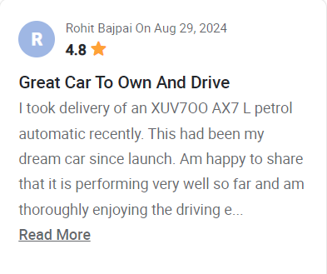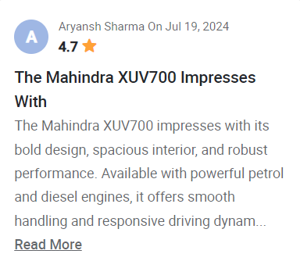

**Hyundai Creta**[10] [11]

* **Strengths**
  + Performance: The Creta has a lot of features, including a touchscreen infotainment system, automatic climate control, and keyless entry.
  + Design: The Creta has a sharp, updated design.
  + Power: The Creta's powertrain is adequate for most driving situations.
  + After-sales support: Hyundai offers good after-sales support, including roadside assistance and responsive customer service.
* **Weaknesses**
  + Ride quality: Some drivers find the ride quality to be firm, especially on rough roads.
  + Headroom: The sloping roofline may limit rear headroom for taller passengers.
  + Base variants: The base variants may not offer good value for money. For example, the EX variant lacks a rear defogger, wiper, camera, parcel tray, and automatic climate control.
  + Price: The top-end models are expensive

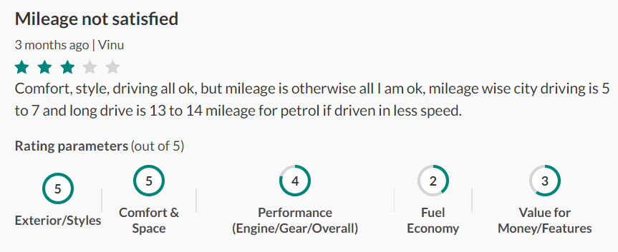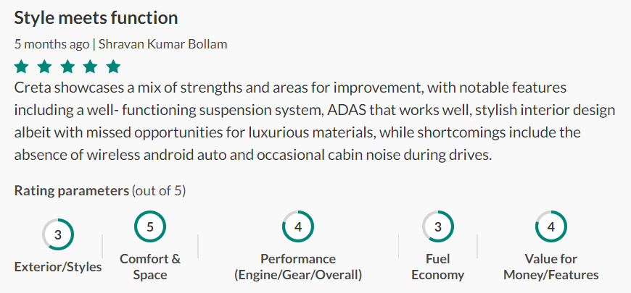

**Toyota Fortuner**[12] [13]

* **Strengths**
  + Off-roading: The Fortuner has good ground clearance, approach and departure angles, and a capable 4x4 system.
  + Interior: The Fortuner has a spacious interior despite its compact exterior.
* **Weaknesses**
  + Ride quality: The Fortuner jiggles over bumps and potholes, and doesn't isolate its occupants well.
  + Driving dynamics: The Fortuner has slow steering, rolls around corners, and nose dives when braking hard.
  + Mileage: The Fortuner's mileage averages around 09 km/l.
  + Suspension: Suspension problems are a common issue with the Fortuner.
  + Infotainment: The Fortuner's 8.0-inch screen is slow to boot up and laggy in day-to-day use.

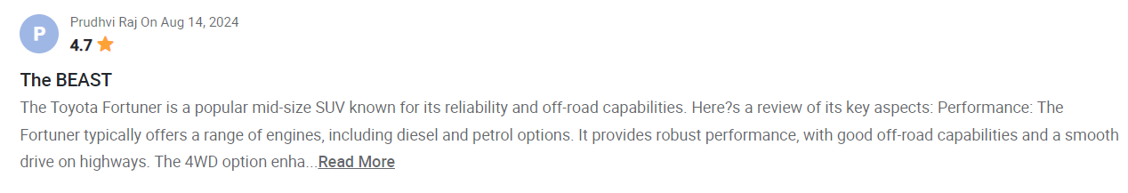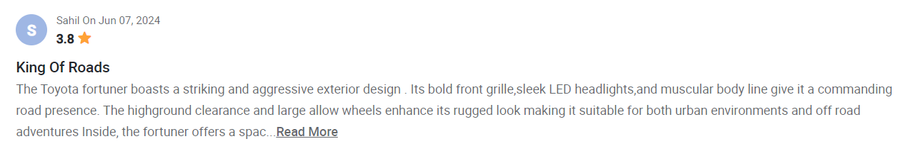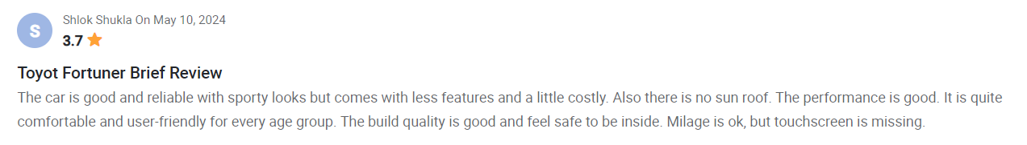

# Pre-Purchase Stage

1. **Problem Recognition**
   * Factors influencing SUV consideration:
     + Weekend trips (42.3%)
     + Family growth (19.2%)
     + Business use (19.2%)

**Insight**: Lifestyle choices, such as the need for weekend travel and anticipation of family growth or business needs, are the primary reasons for SUV consideration.

1. **Purchase Timeline**
   * 1-3 years (40%)
   * 3-5 years (32%)
   * More than 5 years (24%)

**Insight**: Most MBA students plan to make an SUV purchase within 1-5 years, correlating with their expected career progression post-MBA.

1. **Importance of SUV ownership post-MBA**
   * Moderately important (36%)
   * Slightly important (20%)
   * Not important (12%)
   * Very important (12%)

**Insight**: Most respondents see SUV ownership as moderately or slightly important for their post-MBA lifestyle.

1. **Information Search**
   * Top-ranked sources: Automobile review websites, YouTube reviews
   * Less trusted: TV ads, car dealerships

**Insight**: Buyers place more trust in digital reviews and content, shifting away from traditional advertising and physical dealerships.

1. **Brands of interest for test drives**
   * Top brands: TATA and Toyota
   * Least popular brands: MG and Kia

**Insight**: TATA's brand loyalty remains strong, while Toyota also enjoys high interest. However, newer entrants like MG and Kia are less favored for test drives.

## Marketing Implications of Pre-Purchase Stage

**Timing**: Marketing efforts should focus on final-year MBA students and recent graduates, as they represent the segment most likely to make a purchase within the next 1-3 years.

**Messaging**: Emphasize the TATA Harrier’s suitability for weekend getaways and business use. Highlight features catering to growing families.

**Channels**: Prioritize digital marketing through automobile review websites and YouTube content, the most trusted sources. Enhance dealership experiences to increase trust among potential buyers.

**Brand Positioning:** Leverage TATA’s strong brand loyalty and promote the Harrier as a versatile SUV suitable for both personal and professional needs.

**Product Development**: Consider developing features that enhance the weekend travel experience, as this is the primary motivator for SUV purchases. Also, explore adding business-oriented features to cater to those purchasing SUVs for professional use.

## Decision-Making Model: Compensatory Decision Rule

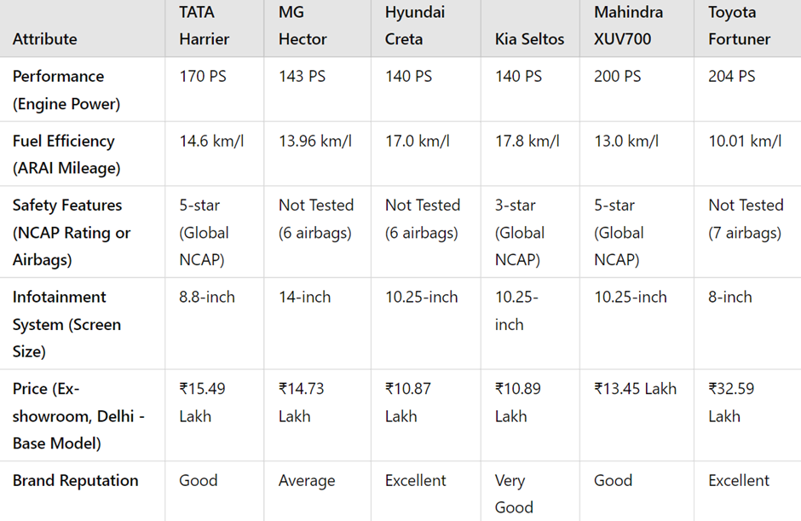Buyers of the Tata Harrier evaluate trade-offs, where they may overlook certain weaknesses (e.g., slightly lower fuel efficiency) in favor of strengths like safety, engine power, and competitive pricing. The Tata Harrier positions itself as a balanced option, offering a blend of safety, performance, and affordability. This appeals to buyers seeking an all-around package, making it a suitable choice for a wide range of needs and preferences.

# Purchase Stage

The purchase stage is a critical phase in the consumer decision-making process, where potential buyers evaluate their options and make a final decision on which product or service to purchase. This stage involves weighing different attributes, comparing alternatives, and balancing personal preferences with practical considerations such as cost, performance, and brand trust. It is the culmination of the consumer’s pre-purchase research and preference formation, leading to a decisive action.

## Correlation Analysis in the Purchase Stage

The correlation matrix presented offers valuable insights into how various factors influence consumer decision-making during the vehicle purchase process. The factors assessed include age demographics, vehicle performance, fuel efficiency, comfort, safety, design, infotainment, price, brand reputation, and resale value. These relationships can be contextualized using consumer behavior frameworks, particularly focusing on the purchase stage of the decision-making process. In the purchase stage, consumers evaluate various alternatives based on their preferences and choose the product that best fits their needs.

**Key Insights**

1. **Age Group Influence on Vehicle Preferences**

* **Negative Correlations Across Age Groups**: The negative correlation between age groups and most factors indicates that as age increases, preferences for performance, comfort, and other features change. Younger consumers (aged 18-21) seem to have different priorities compared to older consumers (aged 29-34).
* Younger groups may prioritize performance and price.
* Older groups might focus more on comfort, fuel efficiency, and   safety.

1. **Performance and Related Features**

* **Positive Correlation with Fuel Efficiency and Comfort**: Consumers who prioritize vehicle performance are also concerned with comfort and fuel efficiency. This suggests that consumers view these factors as complementary. For instance, those who want a high-performance vehicle to expect it to be fuel-efficient and comfortable.
* **Negative Correlation with Safety and Design**: The trade-off between performance and safety suggests that consumers focused on performance may sacrifice safety features to achieve higher power or better design aesthetics.

1. **Comfort Preferences**

* **Comfort** is strongly correlated with   fuel efficiency   and   performance, showing that consumers who prioritize comfort also expect a vehicle that performs well and consumes less fuel.
* This may imply that comfort-conscious buyers prefer a balanced combination of several features rather than focusing on a single attribute, such as performance alone.

1. **Safety and Related Features**

* A strong positive correlation between safety and infotainment and design shows that consumers focused on safety are also likely to prefer vehicles that offer modern technology (infotainment) and attractive design.
* Safety is highly relevant to older age groups, indicating that this is an important factor for consumers in their lifecycle, who may be buying vehicles for family or long-term use.

1. **Infotainment and Design**

* Infotainment and design are closely related to price, suggesting that buyers willing to pay more expect advanced technology and appealing vehicle aesthetics.
* This can be indicative of consumers looking for a premium vehicle experience, where technology and design are perceived as markers of quality.

1. **Price Sensitivity**

* Price(L) and Price(H): These factors are correlated with other attributes like comfort, infotainment, and brand reputation. This indicates that price-sensitive consumers, whether for low or high-priced vehicles, evaluate features such as brand image and infotainment systems during the purchase decision.
* Price-sensitive buyers expect a return on investment in terms of vehicle features, such as technology, comfort, and overall brand value.

1. **Brand Reputation and Resale Value**

* Brand Reputation is positively correlated with   resale value   and   infotainment. This relationship indicates that consumers perceive reputable brands as having better resale value and more modern vehicle technology.
* Consumers in the purchase stage may see brand reputation as a key factor in deciding between different models, given its long-term implications on resale value and trust in the brand.

## Consumer Behavior Frameworks in the Purchase Stage

In the purchase stage, consumers evaluate various products and make a final decision based on their preferences, perceived value, and available information. The following consumer behavior frameworks help explain the correlations observed in this matrix:

1. **The Multi-Attribute Attitude Model**: The   multi-attribute attitude model   suggests that consumers evaluate a product based on several key attributes, each weighed by its importance to the consumer. For instance:

* **Performance, Comfort, and Fuel Efficiency**: Consumers see these features as interconnected, likely assigning significant weight to these attributes during evaluation. The positive correlation between these factors suggests that consumers who prioritize performance also expect comfort and fuel efficiency.
* **Price Sensitivity**: Consumers use price as an indicator of the vehicle's overall value. The correlation between   price, comfort, and   infotainment   suggests that higher-priced vehicles are expected to have more features. In the purchase stage, consumers balance their desired features against the vehicle’s price.
* **Safety and Design**: Safety-conscious consumers also seem to value design and infotainment, which means that they evaluate vehicles based on multiple attributes, assigning greater importance to certain features based on their individual preferences.

1. **Compensatory and Non-Compensatory Decision Rules**:

* **Compensatory Rule**: In this model, consumers may be willing to trade off less critical attributes if a vehicle excels in more important areas. For example, if a vehicle excels in performance   but lacks design, a consumer may still choose it if performance is a top priority.
* **Non-Compensatory Rule**: Conversely, some consumers may reject a vehicle if it fails to meet minimum criteria in key areas. For instance, a safety-conscious buyer might reject a vehicle with poor safety ratings, regardless of its performance or price.

1. **The Theory of Planned Behavior (TPB):**TPB suggests that consumer behavior is influenced by attitudes, subjective norms, and perceived behavioral control. The findings in the matrix can be tied to these elements:

* **Attitudes**: Consumers’ attitudes toward factors like   performance, comfort, and safety   strongly influence their purchasing decisions. The correlations show that consumers form attitudes based on their evaluation of multiple vehicle features.
* **Subjective Norms**: Consumers may also be influenced by external opinions, such as those of family, friends, or social groups, which could explain the importance of   brand reputation   and   safety   features. For example, consumers might prefer brands with strong reputations, driven by social validation.
* **Perceived Behavioral Control**: Consumers’ ability to purchase is influenced by factors like   price   and   resale value. The correlation between price and other features (comfort, infotainment) suggests that consumers may be limited or empowered by their budget when making a purchase.

1. **Heuristics and Biases in Decision-Making:**Heuristics (mental shortcuts) can also play a role in the purchase stage. The correlations reflect some heuristics consumers may use:

* Brand Reputation Heuristic: Consumers might rely on brand reputation as a shortcut, if a well-known brand will have better   resale value   and advanced features like   infotainment.
* Price-Quality Heuristic: Higher-priced vehicles tend to have positive correlations with better   infotainment, comfort, and   design, suggesting that consumers associate higher prices with better quality.

**Key Takeaways**

* Younger consumers may prioritize performance and price, while older consumers focus more on comfort, safety, and fuel efficiency.
* Consumers who value performance tend to expect comfort and fuel efficiency, while those focused on safety also value design and infotainment.
* Brand reputation and price play significant roles, influencing decisions based on expectations of resale value and perceived quality.

## Regression Analysis Results

**Objective:** This report aims to evaluate the relationship between various SUV attributes and the overall customer satisfaction (ratings) using a multiple linear regression model. The independent variables (V3: Performance, V4: Fuel Efficiency, V5: Comfort, V6: Design and Styling, V7: Infotainment, V8: Price, V9: Brand Reputation, V10: Resale Value) are analyzed to understand their influence on the dependent variable (V12: Ratings by Respondents). Additionally, the results are connected to consumer behavior concepts and frameworks, particularly in the purchase stage of the consumer decision-making process.

1. **Model Summary**

**R (Correlation Coefficient):** A value of 0.961 indicates a strong positive correlation between the selected SUV attributes and the overall ratings (V12).

**R Square (Coefficient of Determination):** 92.4% of the variation in customer ratings (V12) can be explained by the attributes under study. This implies that most of the factors influencing customer satisfaction are captured by this model.

**Adjusted R Square:** After accounting for the number of predictors, the Adjusted R Square remains high at 87.6%, confirming the robustness of the model.

**Standard Error of the Estimate:** The standard error is 0.756, indicating a relatively small margin of error in predicting customer satisfaction based on the selected attributes.

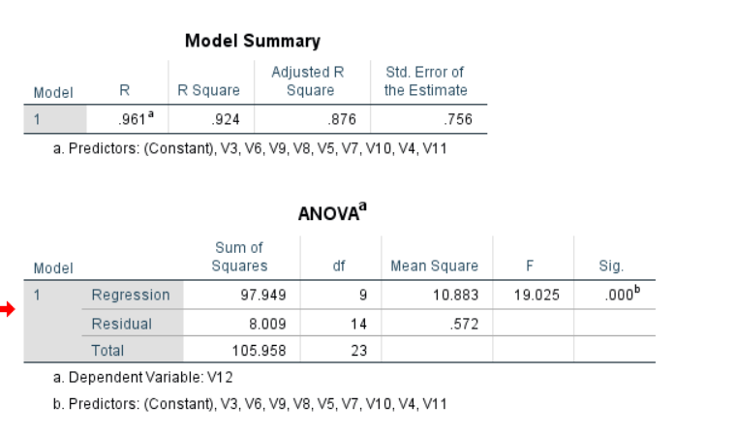

1. **Regression Coefficients**

**Impact:** Fuel efficiency has the most significant effect on overall satisfaction (V12), contributing 1.314 units to the ratings for every unit increase in fuel efficiency rating.

**Consumer Behavior Link:** Fuel efficiency is crucial in the evaluation of alternatives stage of the consumer decision-making process. Consumers may prioritize vehicles with better mileage to minimize long-term operational costs, especially in a price-sensitive market. This aligns with the cognitive dissonance theory, where consumers aim to justify their decision by choosing a cost-effective option.

1. **Price** (V8, B = 0.912, p = 0.008)

**Impact**: Price plays a major role in influencing overall satisfaction, with a coefficient of 0.912. Customers tend to favour vehicles that are perceived as offering good value for money.

**Consumer Behavior Link**: Price sensitivity affects decision-making in the purchase decision stage. Customers are often constrained by their budget and look for vehicles that offer a balance between cost and features. Perceived value is a key determinant of satisfaction and can affect the post-purchase evaluation.

1. **Brand Reputation** (V9, B = 0.751, p = 0.028)

**Impact**: Brand reputation positively impacts customer ratings. A strong brand can increase satisfaction by 0.751 units for every increase in the reputation rating.

**Consumer Behavior Link**: Brand equity and trust play a significant role in the information search and evaluation of alternative stages. Consumers tend to prefer brands they are familiar with or perceive as reliable, which reduces perceived risk. This aligns with the theory of planned behaviour, where subjective norms (influences like brand reputation) affect purchase intention.

1. **Comfort** (V5, B = 0.454, p = 0.191)

**Impact**: Comfort shows a positive relationship with satisfaction, though it is not statistically significant at the 5% level (p = 0.191).

**Consumer Behavior Link**: Comfort influences consumer choices in both the purchase decision and post-purchase evaluation stages. Consumers may rationalize their purchase based on the level of comfort, which ties back to cognitive dissonance reduction, where they justify their decision to ensure consistency between expectations and reality.

1. **Performance** (V3, B = 0.458, p = 0.144)

**Impact**: Performance is moderately important to customers, but it is not statistically significant in this model (p = 0.144).

**Consumer Behavior Link**: Performance influences purchase decisions, particularly for consumers prioritizing vehicle power and driving experience. However, the lack of significance in the model suggests that other factors like fuel efficiency and price may take precedence in the decision-making process for the majority of consumers.

1. **Non-Significant Predictors**- **Design and Styling** (V6, B = 0.259, p = 0.625)

**Impact**: Design and styling appear to have minimal influence on satisfaction (p = 0.625).

**Consumer Behavior Link**: While aesthetics might affect first impressions and influence the evaluation of alternatives, it seems that consumers in this study prioritize more functional aspects (fuel efficiency, price, etc.) over design in their post-purchase satisfaction.

1. **Infotainment** (V7, B = 0.043, p = 0.919)

**Impact:** Infotainment has an insignificant effect on satisfaction.

**Consumer Behavior Link**: This suggests that infotainment systems, while important for enhancing the driving experience, are not a major determinant of overall customer satisfaction in the purchase decision.

1. **Resale Value** (V10, B = -0.052, p = 0.869)

**Impact**: Resale value does not appear to play a significant role in influencing overall satisfaction (p = 0.869).

**Consumer Behavior Link**: Resale value may be more relevant in the post-purchase evaluation stage when consumers consider the long-term financial aspects of their purchase. However, it seems that in the immediate purchase stage, consumers are not as concerned about resale value.

1. **Implications for Consumer Behavior and Purchase Decisions**

The results of this regression analysis align with key concepts in consumer behavior, particularly in understanding how various attributes influence the purchase stage and post-purchase satisfaction:

**Multi-Attribute Attitude Model**: This framework explains how consumers evaluate products based on several attributes and assign a weight to each factor. The significant predictors in this model (fuel efficiency, price, and brand reputation) highlight the attributes that are most important to customers when purchasing an SUV.

**Theory of Planned Behavior:** The strong influence of brand reputation reflects the role of subjective norms in the decision-making process. Consumers are influenced by external factors, such as brand image and reputation, which guide their purchase decisions.

**Cognitive Dissonance Theory:** Post-purchase satisfaction (as measured by V12) is influenced by factors like fuel efficiency and price, which are key to reducing cognitive dissonance. Consumers tend to be more satisfied when their purchase aligns with their initial expectations and helps reduce the psychological discomfort of making a high-cost decision.

**Decision-Making Process:** In the evaluation of alternatives, consumers seem to focus heavily on fuel efficiency and price. These factors directly relate to functional and economic benefits.In the purchase stage, brand reputation helps alleviate risk and drives purchase decisions.

Post-purchase evaluation, measured through satisfaction (V12), shows that consumers may rationalize their choices based on factors like fuel efficiency and price.

**Key Interpretation**

The analysis demonstrates that fuel efficiency, price, and brand reputation are the most significant factors influencing customer satisfaction when purchasing an SUV. These attributes play a critical role in shaping consumer behavior during the evaluation of alternatives and the purchase decision stage.

**Fuel efficiency** is the top contributor to post-purchase satisfaction, suggesting that consumers are highly conscious of operational costs and long-term savings.

**Price** is a key determinant, indicating that customers are price-sensitive and prioritize vehicles that provide perceived value for money.

**Brand reputation** plays a substantial role in driving customer satisfaction, as consumers tend to trust well-established brands, viewing them as reliable and lower risk.

Less significant factors, such as design and styling, infotainment, and resale value, indicate that while these attributes may be important during initial consideration, they do not have a strong impact on overall satisfaction after the purchase has been made.

From a consumer behavior perspective, this aligns with the multi-attribute attitude model, where consumers weigh different attributes to form an overall evaluation of a product. The importance of fuel efficiency and price also highlights the role of cognitive dissonance reduction—customers are more satisfied when their purchase aligns with their expectations of practicality and cost-effectiveness.

**Implications for Marketers**

Marketers should focus on emphasizing fuel efficiency and value for money in their campaigns, as these attributes are the most influential in driving purchase decisions and post-purchase satisfaction. Additionally, strengthening brand reputation through positive customer experiences and maintaining reliability will enhance consumer trust and brand loyalty. In contrast, while aspects like infotainment and design might help in capturing initial interest, they are less likely to have a lasting impact on overall customer satisfaction.

**Final Thoughts**

The **correlation analysis** highlights the importance of **performance**, **comfort**, and **design** during the purchase decision-making stage, the **regression analysis** shows that these factors are not as critical in driving post-purchase satisfaction. This can be explained by the **difference between what consumers expect** at the point of purchase and what ultimately influences their satisfaction after experiencing the vehicle.

* **Performance and Comfort**: Though highly considered during purchase, they may not deliver as much impact on overall satisfaction post-purchase.
* **Design and Infotainment**: Initially influential for **safety-conscious buyers**, but they fade in importance once the vehicle is owned and practical, functional benefits like **fuel efficiency** and **price** take precedence.

# Post-Purchase

This analysis focused on the period after customers purchased the Tata Harrier, exploring several key areas:

**Customer Satisfaction**: This area investigated the aspects of the Tata Harrier that customers were satisfied or dissatisfied with after purchasing the vehicle. It helped assess if the product met or exceeded expectations.

**Cognitive Dissonance**: The research investigated whether buyers had second thoughts or regrets after their purchase and how this affected their overall satisfaction and likelihood of recommending the car to others.

**Word of Mouth (WOM):** The study also examined how likely customers were to recommend the Tata Harrier to others. WOM behaviour is critical for brand loyalty and can significantly influence future sales.

## Analysis

**Significance (P-value):** With a p-value of 0.835 (which is much higher than the conventional threshold of 0.05), the relationship between cognitive dissonance and WOM behaviour is not statistically significant. Therefore, there is no substantial evidence that regret influences a customer’s likelihood to recommend the vehicle.

**Descriptive Statistics**: Descriptive statistics were used to summarize how satisfied customers were, whether they experienced regret, and their likelihood of recommending the Tata Harrier. Most participants reported minimal or no cognitive dissonance, and even in cases of mild regret, overall satisfaction was not drastically affected.

**Correlation Test:** A correlation analysis was conducted to determine whether there was any significant relationship between Cognitive Dissonance and Word of Mouth behaviour.

**Pearson Correlation Coefficient**: The value of 0.043 suggests a very weak positive relationship between cognitive dissonance and word-of-mouth behaviour. In simpler terms, the presence of regret post-purchase does not appear to meaningfully affect whether customers recommend the Tata Harrier. This means that whether customers experienced regret does not have a substantial impact on their willingness to recommend the car.

**NPS Calculations**

The net promoter score on calculation came to be 15%. This substantiates the fact that though they experience some amount of cognitive dissonance the customers are happy with the brand, and it doesn’t deter them promoting the brand

**Key Insights**

The analysis found that cognitive dissonance, or post-purchase regret, minimally affects Tata Harrier owners' likelihood of recommending the vehicle. Most instances of regret were minor and did not significantly impact overall satisfaction. Despite occasional minor regrets, owners are generally satisfied enough to recommend the Tata Harrier to others, indicating strong positive word-of-mouth. Overall customer satisfaction with the Tata Harrier remains high, with insignificant correlations suggesting that minor regrets do not substantially alter satisfaction levels or advocacy for the vehicle. Addressing these minor concerns could further enhance the ownership experience and bolster brand loyalty among Tata Harrier owners.

# Recommendations

## Marketing Problems

1. **Limited awareness among younger buyers**:  Younger buyers are less familiar with the Tata Harrier brand compared to rival SUVs. Out of the 27 surveyed individuals, only 5 were knowledgeable about the Harrier, highlighting a noticeable lack of awareness. This may be due to Tata's limited push in marketing towards younger demographics, who generally have a preference for digital, interactive material. Moreover, social media trends and influencers have a greater impact on younger consumers, a demographic in which Hyundai and Kia are more prominent brands. In order to attract this specific group of people, Tata needs to update its marketing strategies by using digital channels, partnering with influencers, and presenting the Harrier as a modern and technology-oriented option in the SUV market.
2. **Quality and Reliability Issues**: Several Harrier customers have reported experiencing repeated problems like system glitches, clutch issues, and automatic seat malfunctions. If not dealt with quickly, these issues could damage Tata's reputation and steer potential customers towards rival companies. Dependability is crucial in the SUV market, as consumers anticipate high-end features and lasting reliability. Ongoing complaints about these problems may lead to a decrease in customer trust and market participation. In order to uphold consumer trust, Tata needs to promptly deal with these quality issues, guaranteeing that product dependability is in line with rivals to maintain its market position.
3. **Intense Competition**: The market for SUVs in India is fiercely competitive, with Hyundai Creta, Kia Seltos, and MG Hector being key players in the industry. The Harrier faces difficulty standing out due to competitors offering a wide range of features, strong brand visibility, and competitive pricing. The Hyundai Creta and Kia Seltos are popular among budget-conscious buyers due to their advanced technology, appealing design, and affordability. In order to stay competitive, Tata needs to set the Harrier apart by providing distinct advantages like better performance, improved post-purchase assistance, and special features not found in other competing vehicles.

## Marketing Opportunities

1. **Diesel engine SUV**: The powerful diesel engine of the Tata Harrier stands out as a major advantage, offering superior performance in comparison to the petrol choices offered by competitors such as Kia Seltos and MG Hector. This is especially attractive to customers who value power, fuel efficiency, and durability, particularly for long trips or in areas where diesel engines are preferred. Tata can take advantage of this situation by emphasizing the benefits of its diesel engine, which include better torque, fuel efficiency, and effectiveness in tough environments. Catering to a rising population of consumers who prioritize performance, highlighting the advantages of the diesel engine can set the Harrier apart.
2. **Focus on Robust Build Quality**: The Tata Harrier's strong construction is attractive to numerous Indian customers who prioritize safety and endurance. Customer feedback frequently praises the Harrier for its sturdy build, able to tackle challenging road conditions while offering a feeling of safety. By highlighting these attributes, Tata can present the Harrier as the perfect option for customers looking for a dependable, durable, and secure car. Concentrating on safety features, crash-test ratings, and quality construction materials can appeal to customers who value these factors when making a purchase.
3. **Leveraging Tata's Trusted Reputation**: By highlighting the Harrier's Indian roots, Tata Motors has the opportunity to leverage its strong brand reputation and take advantage of the increasing preference for locally-made products. By capitalizing on growing nationalism and a preference for homegrown products, Tata has the opportunity to promote the Harrier as a vehicle that bolsters the local economy. Additionally, Tata has a track record of providing advanced safety features such as multiple airbags, electronic stability control, and reinforced body structures, which boosts consumer trust. By emphasizing these qualities, Tata can enhance its reputation as a trustworthy brand that prioritizes safety and appeal to customers who prioritize both safety and the support of local enterprises.

# Exhibits

|  |  |
| --- | --- |
| **Exhibit 1: Consumer Market Analysis Framework** | |
| **Pre-purchase Stage** | |
| Problem Recognition | o   Factors prompting SUV purchase consideration (Q1) |
| o   Anticipated purchase timeline (Q2) |
| o   Importance of SUV ownership post-MBA (Q3) |
| Information Search | o   Trusted information sources (Q4) |
| o   Brands of interest for test drives (Q5) |
| **Purchase Stage** | |
| Evaluation of Alternatives | o   Importance of SUV attributes (Q6) |
| o   Ratings of SUV models on attributes (Q7) |
| o   Most likely SUV model to purchase (Q8) |
| o   Budget considerations (Q9) |
| **Post-purchase Stage** | |
| Satisfaction/Dissatisfaction | o   Overall satisfaction with familiar SUV (Q11) |
| o   Most satisfying aspects (Q12) |
| o   Areas for improvement (Q13) |
| Word of Mouth | o   Likelihood to recommend (Q14) |

|  |
| --- |
| **Customer Characteristics** |
| Demographics: Age (Q15), Gender (Q16) |
| Academic: MBA specialization (Q17) |
| Professional: Work experience (Q18), Career aspirations (Q19) |
| Perceptions: Impact of SUV on professional image (Q20) |
| Market Insights: Significant trends in SUV market (Q21) |

|  |  |  |  |  |  |  |  |  |  |  |  |  |  |  |  |  |  |  |  |  |  |  |  |  |  |  |
| --- | --- | --- | --- | --- | --- | --- | --- | --- | --- | --- | --- | --- | --- | --- | --- | --- | --- | --- | --- | --- | --- | --- | --- | --- | --- | --- |
| |  |  |  | | --- | --- | --- | | **Exhibit 2: Theoretical Linkages to the Project Framework** | | | | **Concept** | **Question Numbers** | **Marketing Mix Impact** | | Problem Recognition | Q1, Q2, Q3 | Product, Promotion | | Information Search | Q4, Q5 | Promotion, Distribution | | Multi-attribute Choice Models | Q6, Q7 | Product, Price | | Purchase Decision | Q8, Q9 | Product, Price | | Post-purchase Behaviour | Q10, Q11, Q12, Q13, Q14 | Product, Promotion | | Customer Characteristics | Q15, Q16, Q17, Q18, Q19, Q20, Q21 | Marketing Mix | |  |  |

|  |  |  |  |  |
| --- | --- | --- | --- | --- |
| **Exhibit 3: Level 1 Analysis: Purchase Process** | | | | |
| **Behaviour/Question** | **Product** | **Price** | **Distribution** | **Promotion** |
| Q1: Factors prompting purchase | X |  |  | X |
| Q2: Purchase timeline | X | X |  |  |
| Q3: Importance of ownership | X |  |  | X |
| Q4: Information sources |  |  | X | X |
| Q5: Brands for test drive | X |  | X |  |
| Q6: Attribute importance | X | X |  |  |
| Q7: Brand ratings | X | X |  | X |
| Q8: Likely purchase choice | X |  |  |  |
| Q9: Budget considerations |  | X |  |  |

# References

<https://www.team-bhp.com/news/5-repetitive-annoying-issues-i-faced-my-new-tata-harrier>

[Tata Harriers Pros & Cons (Advantages & Disadvantages); Read Our Tata Harrier Review (Detailed) - DriveSpark News](https://www.drivespark.com/four-wheelers/2018/tata-harrier-pros-cons-advantages-disadvantages-review-detailed-027026.html)

<https://gomechanic.in/blog/your-next-car-is-tata/>

[Tata Harrier Reviews & Rating - Harrier User Reviews (91wheels.com)](https://www.91wheels.com/cars/tata/harrier/reviews?utm_source=msn&utm_medium=cpc&utm_campaign=DSA-Car-Make-Tata-EV&matchtype=b&device=c&campaignid=521202829&loc_physical_ms=1647&network=o&keyword=cars%2Ftata%2F%20ev&placement=&loc_interest_ms=&msclkid=fd3de32b86b314ae5d0285c128c7def0)

[Sales analysis: How was the Indian passenger car market in Q1 2024 | Team-BHP](https://www.team-bhp.com/news/sales-analysis-how-was-indian-passenger-car-market-q1-2024)

[India Hybrid Vehicles Market Size & Share Analysis - Industry Research Report - Growth Trends (mordorintelligence.com)](https://www.mordorintelligence.com/industry-reports/india-hybrid-vehicles-market)

1. <https://www.carwale.com/tata-cars/harrier/#:~:text=The%20168bhp/350Nm%202.0%2Dlitre,seated%20comfortably%20at%20the%20rear>.
2. <https://www.evoindia.com/top-news/2023-tata-harrier-facelift-first-drive-review#:~:text=It%20continues%20to%20be%20just,2023%20Harrier%20facelift%20down%20below>!
3. <https://www.youtube.com/watch?v=fFY_DQEeOps>
4. <https://www.carwale.com/mg-cars/hector-2021-2023/user-reviews/371145/#:~:text=It's%20safe%20to%20assume%20that,at%20high%20speeds%20with%20stability>.
5. <https://www.carandbike.com/news/planning-to-buy-the-mg-hector-here-are-the-pros-and-cons-2582044>
6. <https://www.motortrend.com/reviews/2021-kia-seltos-yearlong-review-update-5-pros-and-cons/>
7. <https://www.timothyabeel.com/blog/2022-kia-seltos-problems/#:~:text=The%202022%20Kia%20Seltos%2C%20a,malfunctions%2C%20and%20glass%20quality%20concerns>.
8. <https://www.team-bhp.com/forum/official-new-car-reviews/240680-mahindra-xuv700-review.html#:~:text=The%20first%20one%20is%20a%202.0%2Dlitre%20turbocharged,6%2Dspeed%20MT%20in%20the%20MX%20(base)%20variant>.
9. <https://auto.hindustantimes.com/auto/cars/mahindra-xuv700-pros-and-cons-worth-the-wait-41643261500870.html#:~:text=Mahindra%20XUV700%20cons:&text=A%20string%20of%20factors%2C%20including,Post%2Dsales%20service>:
10. <https://www.cardekho.com/hyundai/creta/specs>
11. <https://www.carwale.com/hyundai-cars/creta/user-reviews-p2/>
12. <https://www.cardekho.com/user-reviews/toyota-fortuner>
13. <https://www.carwale.com/toyota-cars/fortuner/expert-reviews/Toyota-Fortuner-Review-Pros-and-Cons/>